# Lecture 1 : Steps and Resources to learn LLD as a beginner

# Lecture 2 : What is LLD(Low Level Design)

# Lecture 3 :  How to design low level applications using objects and classes

# Lecture 4 : How to build Classes in Object Oriented Design

# Lecture 5:- Single Responsibility Principle in SOLID

# Lecture 6 :- open closed principle ----  Inheritance and Polymorphism

# Lecture 7 : Liskov Substitution Principle

# Lecture 8 : interface segregation principle

# Lecture 9 :  Dependency Inversion Principle

# Lecture 10 : design pattern

# Lecture 11 - types of design pattern

# Lecture 12 : How to use Factory Method Design Pattern

# 

# 

# Lecture 1 : Steps and Resources to learn LLD as a beginner

# 

# 

# second one is class diagram, sequence diagram

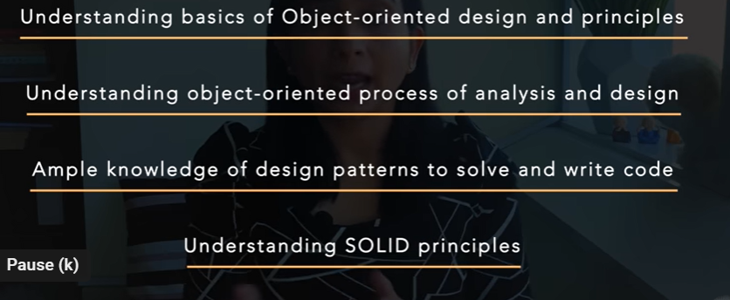

# Lecture 2 What is LLD(Low Level Design)

# What is lld ?

# Lld refers to the design of small components in an application that serves a set of business requirements

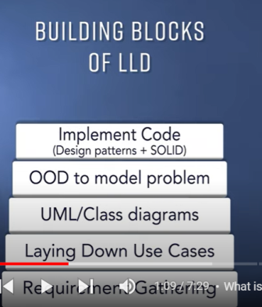

Note :

**Class diagram :-**  reflect the real world problem in terms of classes, relationship with other classes how they interact with other classes, responsibility of every class in terms of method and function, and the data they hold in terms of class attributes

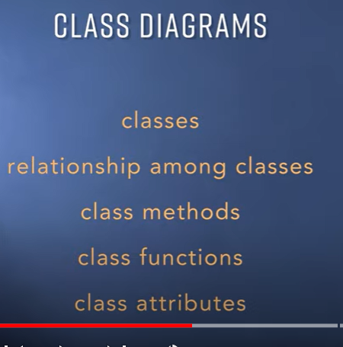

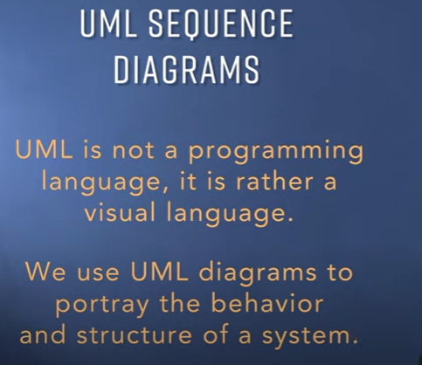

In complicated system design class diagram is complicated hence we use uml sequence diagram

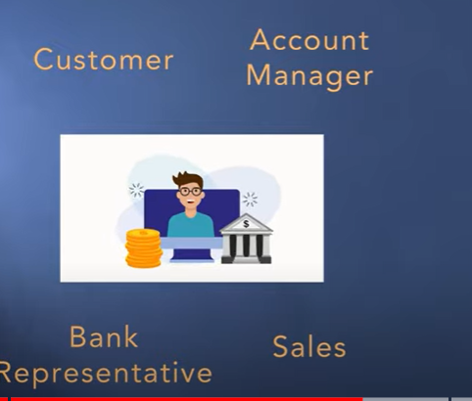

Use cases diagram (will be diff for all above) will help how it will look like

## What is a use case diagram?

In the Unified Modeling Language (UML), a use case diagram can summarize the details of your system's users (also known as actors) and their interactions with the system. To build one, you'll use a set of specialized symbols and connectors. An effective use case diagram can help your team discuss and represent:

**-------------Once all the class diagram, sequence diagram, activity diagram ready**

**------------- write code using solid principles or design pattern**

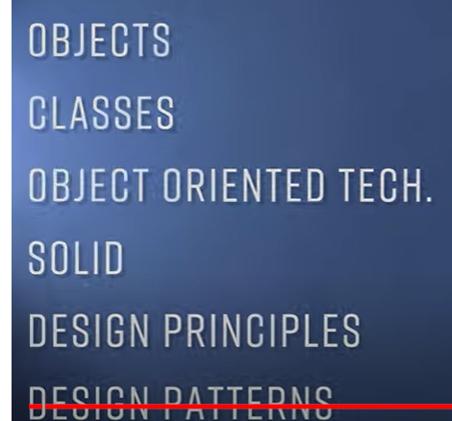

# Lecture 3 :  How to design low level applications using objects and classes

# 

# Object oriented design is not same as object oriented programming

# 

# 

**Ood (**like inheritance, polymorphism, abstraction, encapsulation)

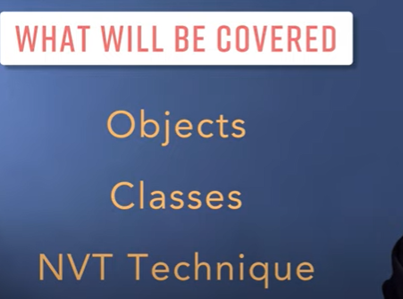

**Nvt technique** :- where we can convert user requirement into classes

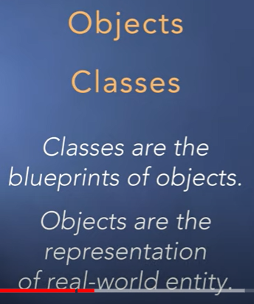

Object :----- consist of two thing **information and behavior**

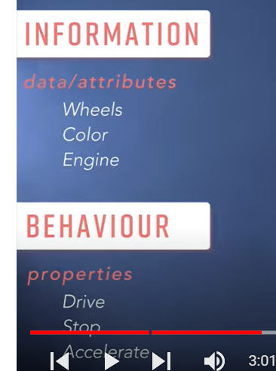

Any real or physical world entity which comprises of these two thing( **information and certain behavior**) can be classified as **object**

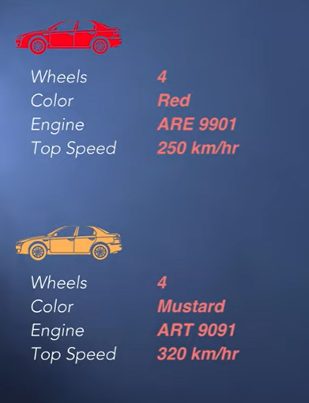

**NVT(Noun verb technique)**

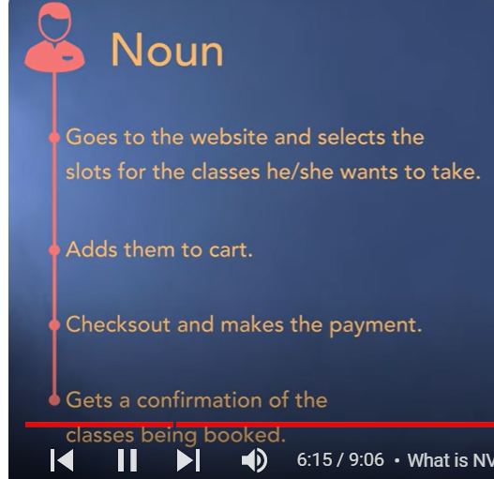

**Noun** : - is considered as classes

By identifying the noun actually we are identifying the classes in the system

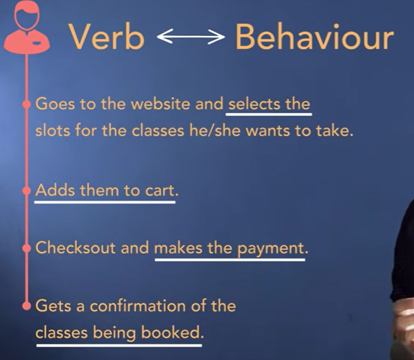

Class diagram :----looks like

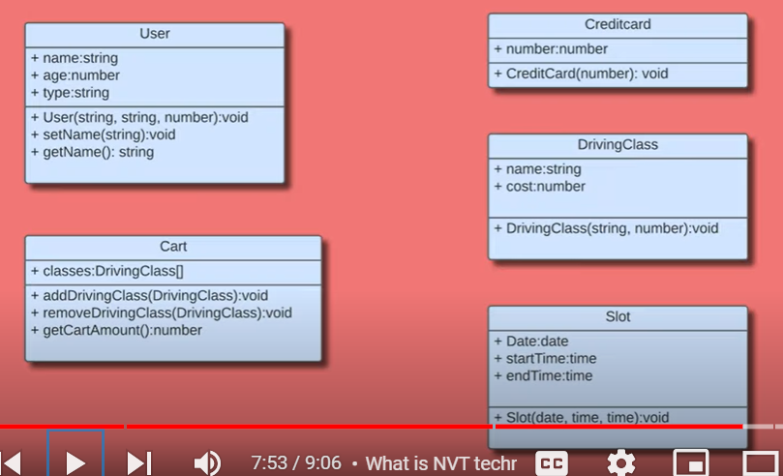

# Lecture 4 : How to build Classes in Object Oriented Design

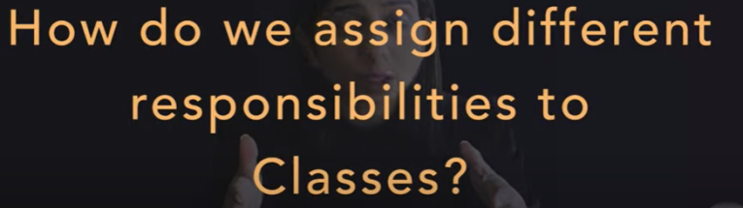

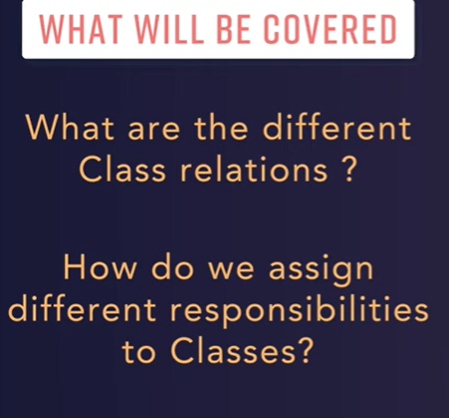

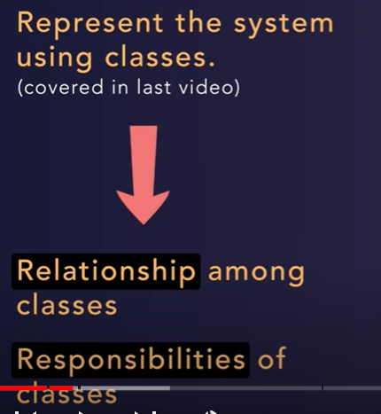

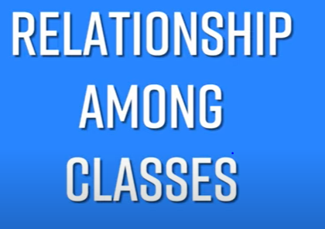

**Note** : 2 kind of r/s among classes

Has a relation or is a relation

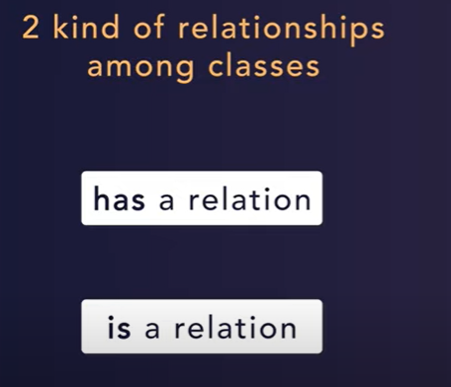

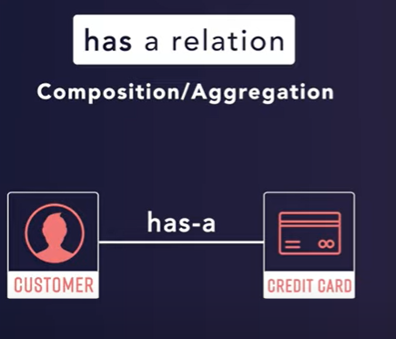

Has a relation ------------------- among classes.

**Example :** a customer can have credit card but there is no existence of **credit card without customer**

**Customer has a credit which**  will show by this diamond and called composition

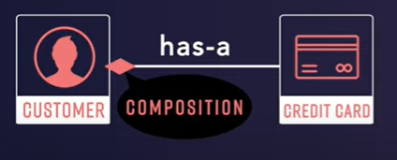

In Java, **aggregation represents a "has-a" relationship**, where one class contains another class as part of its structure, but they can exist independently. Example: A university "has" departments. Composition is a stronger relationship, where one class owns another class, and the owned class cannot exist independently

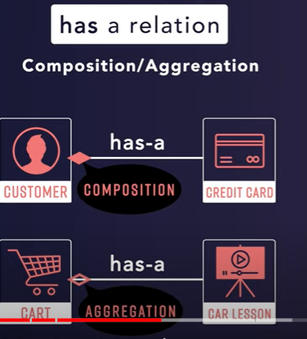

**2 relation :---- is a relation -------------------** **usually point to inheritance**

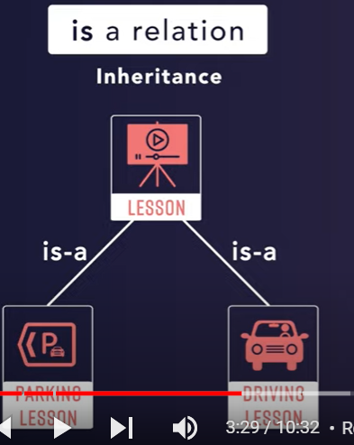

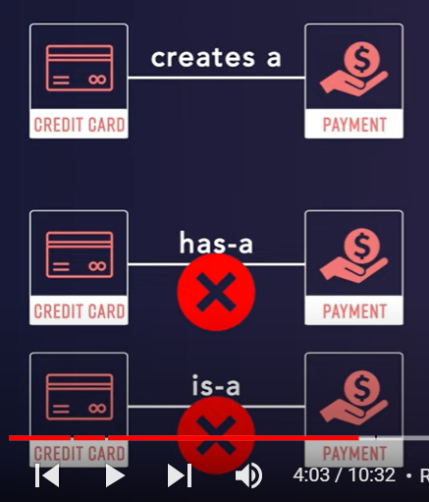

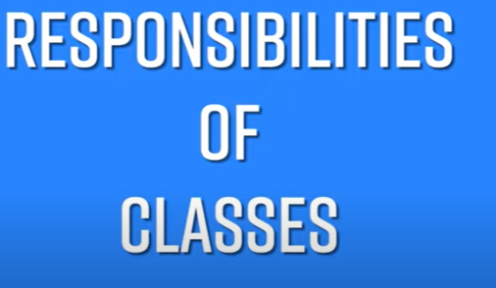

Lesson/item

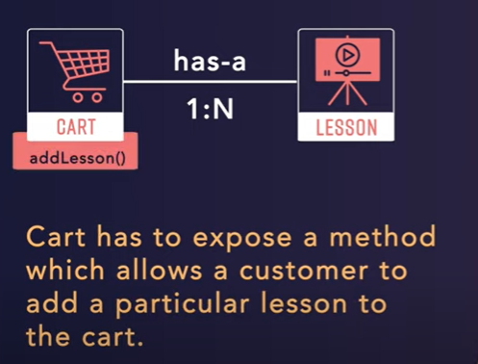

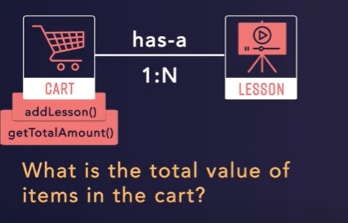

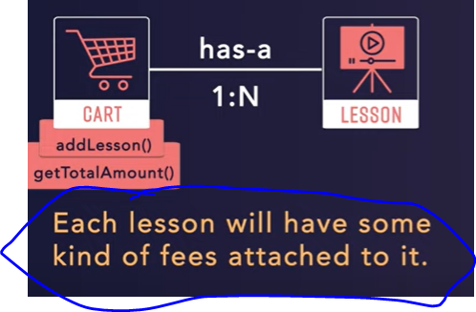

Will give checkout responsibility to customer class

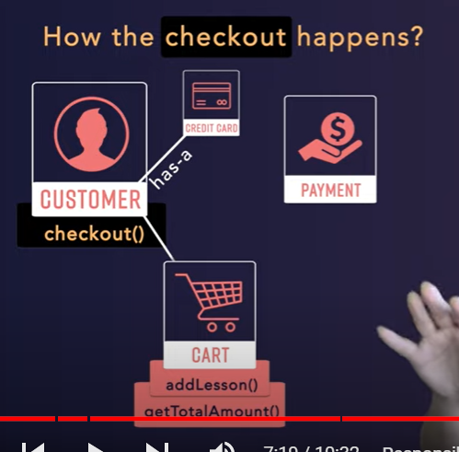

**Abstraction** : customer have the knowledge invoking something but don’t know how it works

encapsulation = data hiding + abstraction

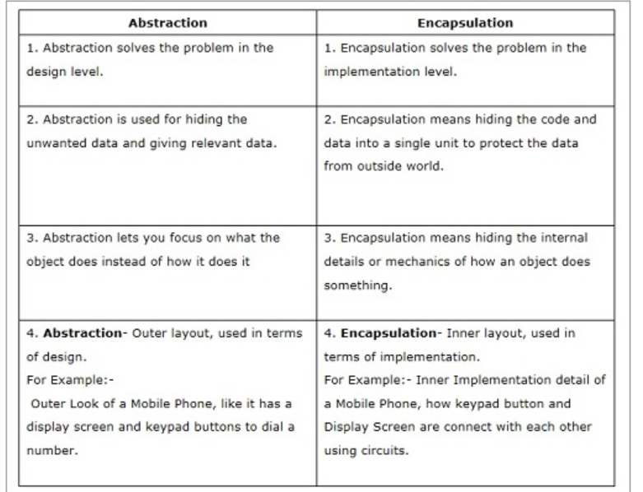

# Lecture 5:- Single Responsibility Principle in SOLID

# 

# An actor is an entity which communicates to other actor by message passing. Actor has it's own state and behavior.

# 

# the whole module should be change by only one actor

# 

# Note : there are three actor written in one class

# 

# 

# getRegularHour use by both and if CFO change it then HR will get failed

# one actor might not know other actor

# 

A class can contain more than one public method. As long as this change is done by one actor or one primary stackholder(or group of stackholder) this is fine but if more than once actor try to change then it may break the **Single responsibility principle**

**How to solve this ?**

**By decomposing**  one classes to multiple classes

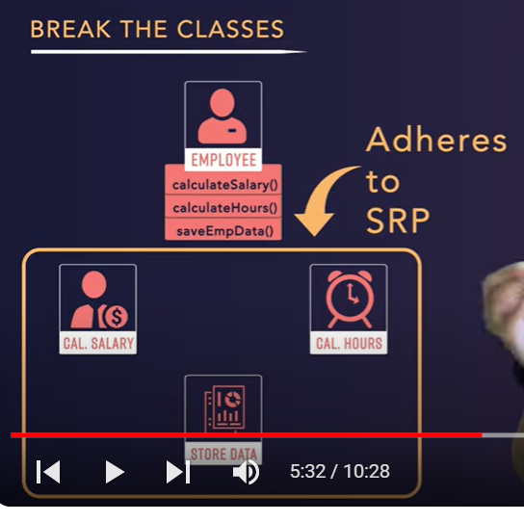

**All these class will call from diff parts of program and calculation of salary does not need to depend on any method**

**Note :**

**If one module class changes by diff business function** means something wrong is going on

# Lecture 6 :- open closed principle ----  Inheritance and Polymorphism

# 

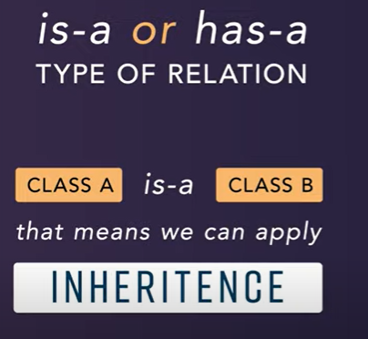

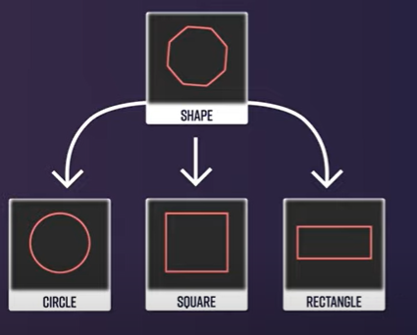

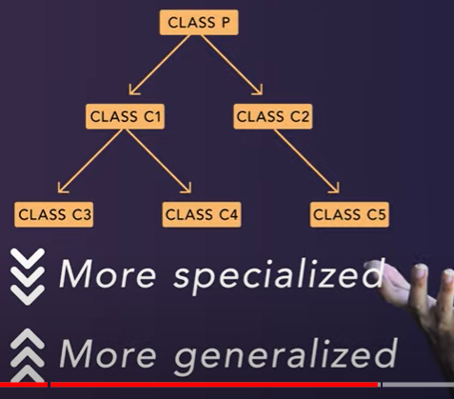

**As we go deeper in inheritance it is more generalized.**



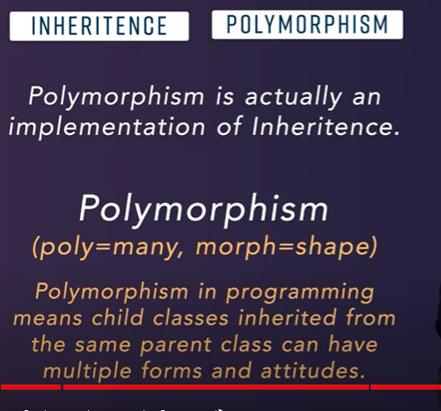

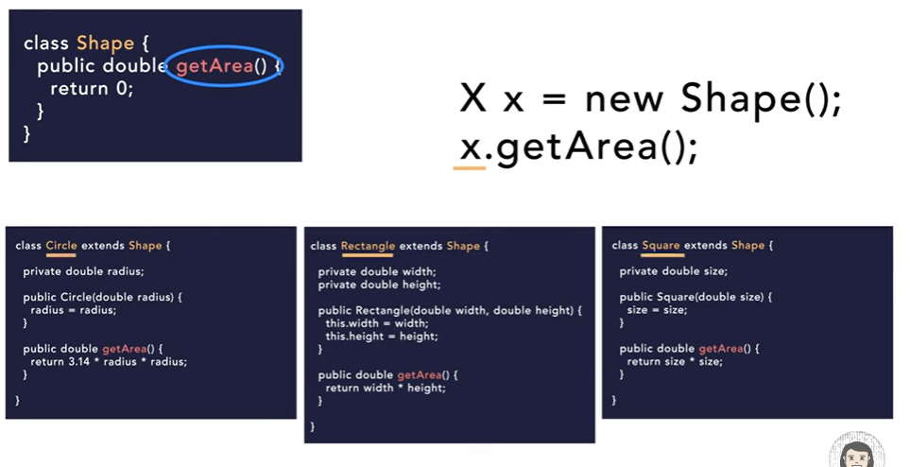

# Lecture 7 : Liskov Substitution Principle

# 

**Principle says : actual class instance we can replace by subclass instance**

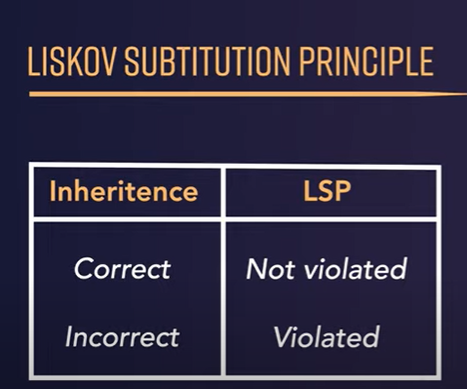

**If inheritance done properly this principle is not violated but if inheritance not done properly this principle is violated**

**------------------------------real world examples**

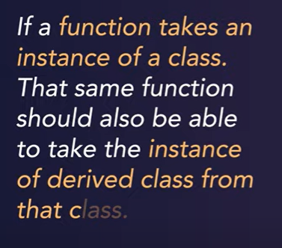

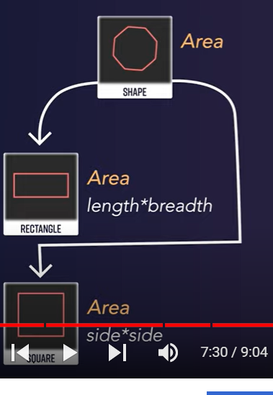

**Note :** the client code which is calling getArea(), it should not break existing function functionality

Check :- replace instance of parent class with child class and see if functionality break

**Lecture 8 : interface segregation principle**

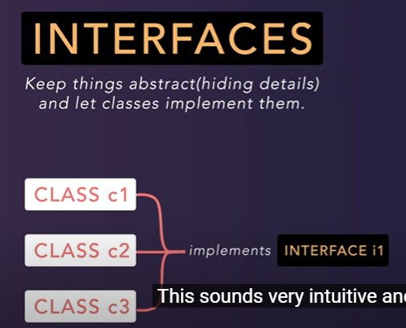

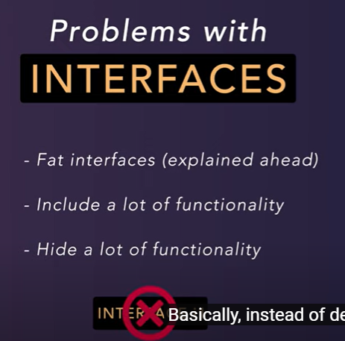

**Note : you should segregate your interface as much as you can**

**And complex interfaces design smaller interfaces**

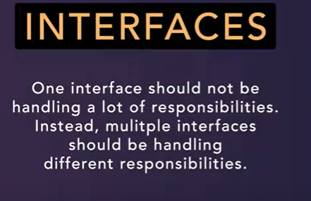

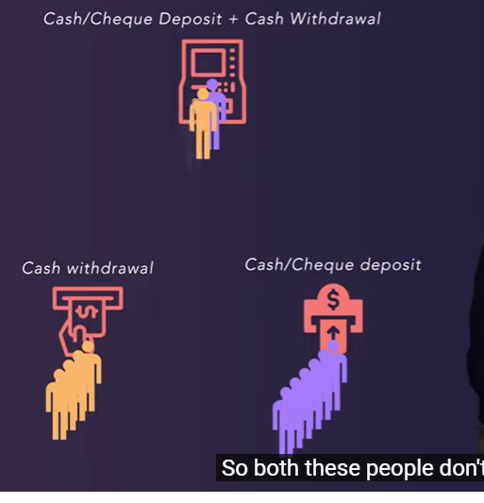

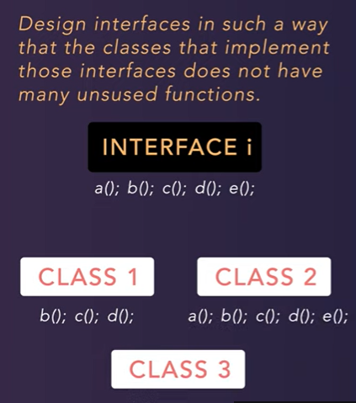

**Create separate interface**

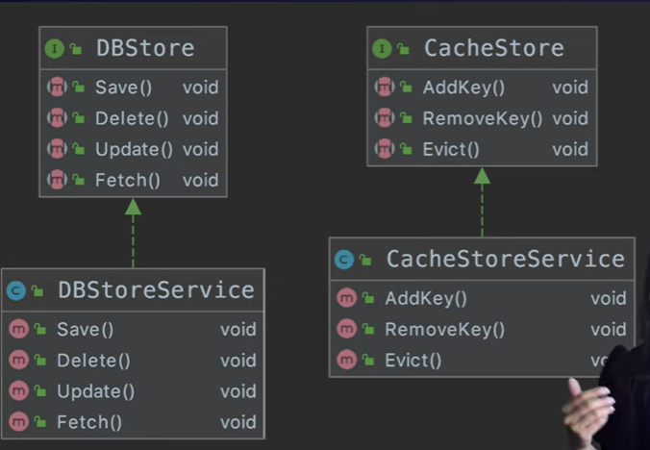

# Lecture 9 :  Dependency Inversion Principle

# 

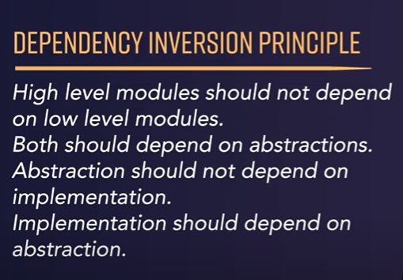

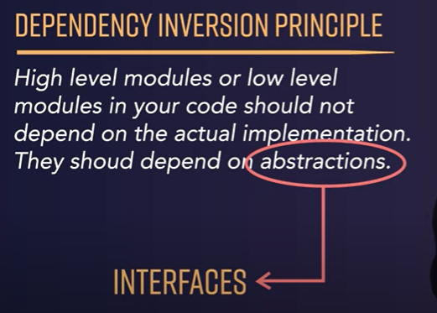

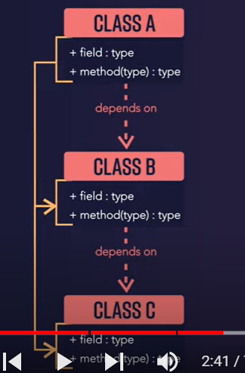

**Mocking is more and difficult to test**

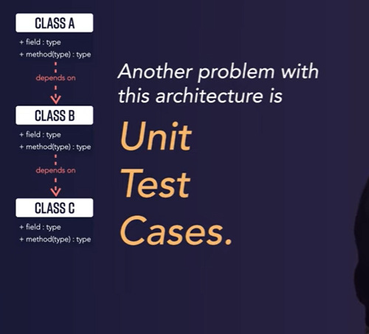

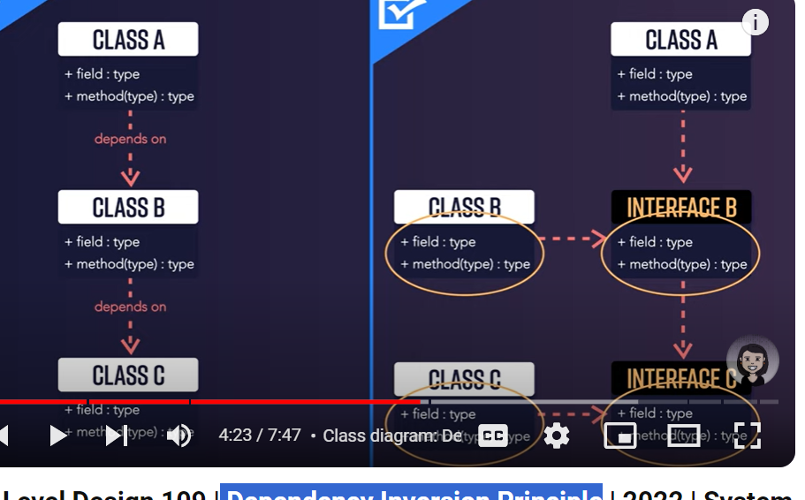

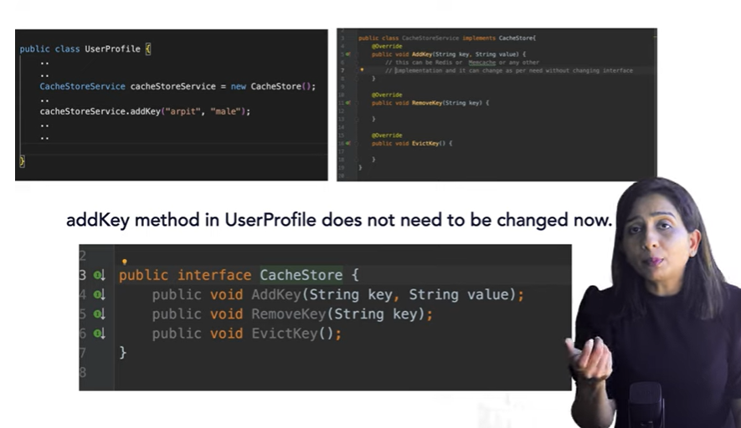

**Here implementation of function can be change but still interfaces having same method so class which implement it don’t need to change**

**Lecture 10 : design pattern**

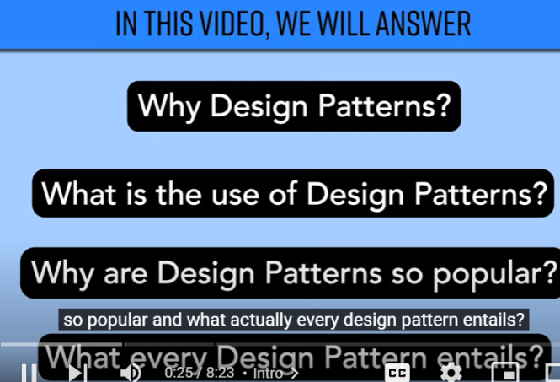

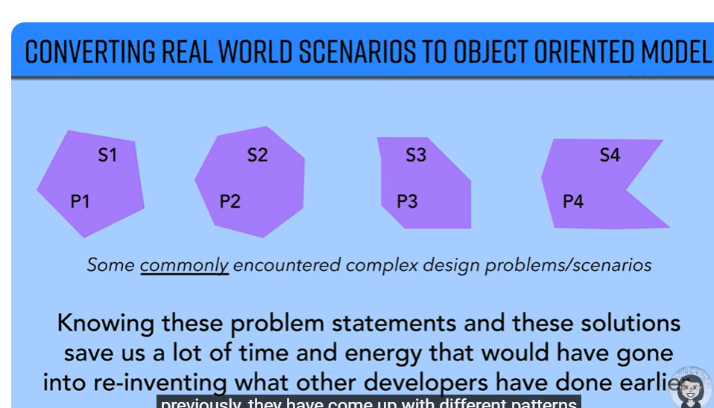

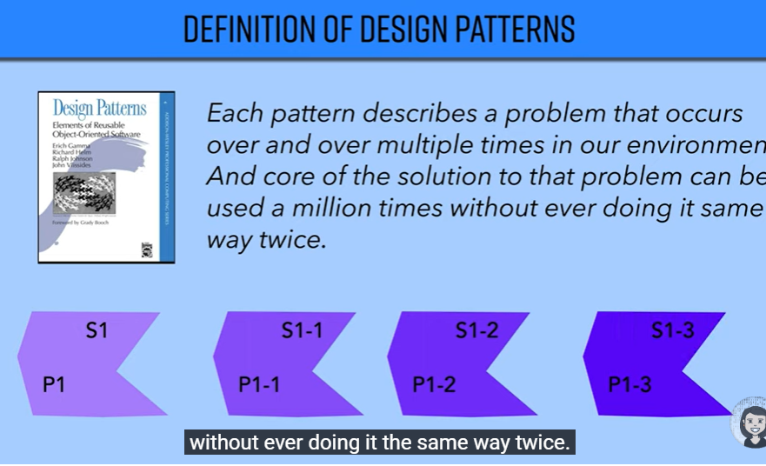

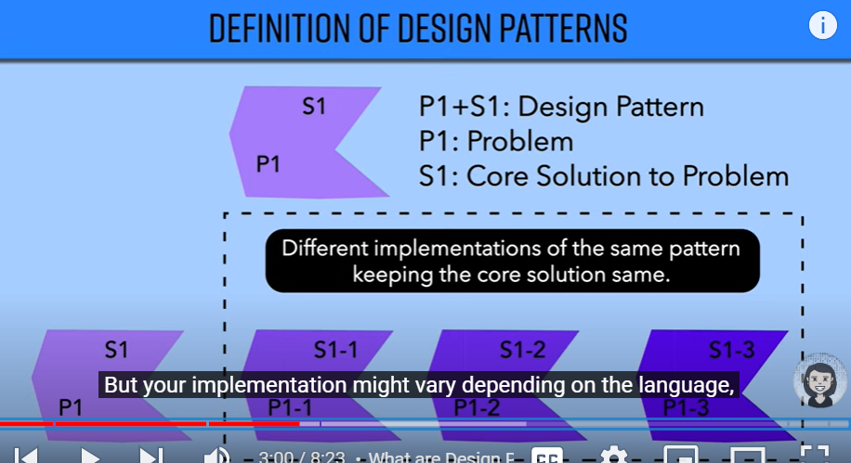

**one design pattern can be implemented in different ways in order to solve similar problems but implementation of those pattern can or cannot be same**

**any design pattern consists of four parts**

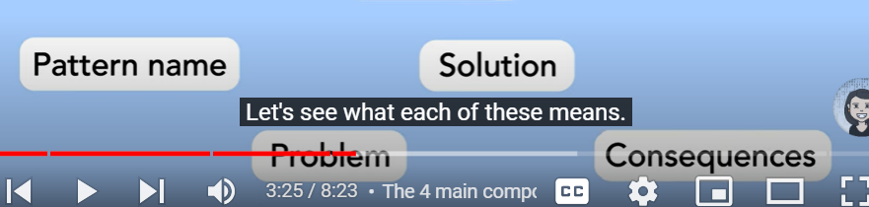

**Pattern describe the problem which is going to solve**

**So design pattern describe the problem and the solution**

**Lecture 11 - types of design pattern**

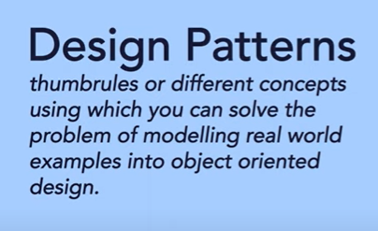

**What is the purpose that design pattern solve.**

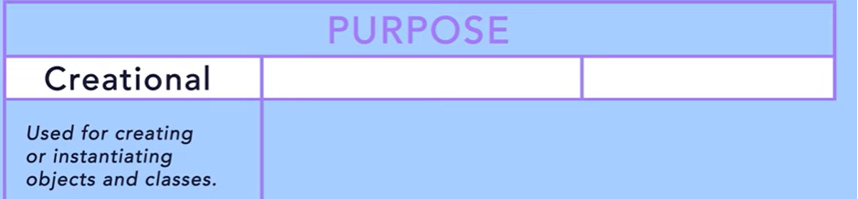

Use for structuring more than one classes or object together

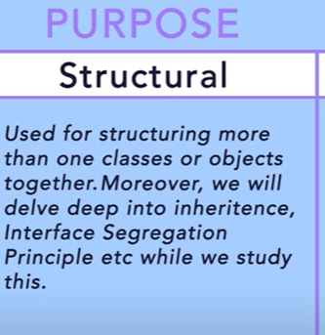

Once we create an object and structure it then behavior will come into picture

**Behavior :---saving data , fetching data**

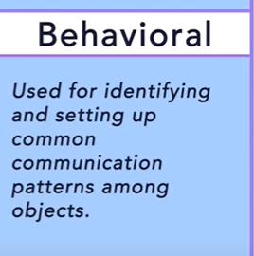

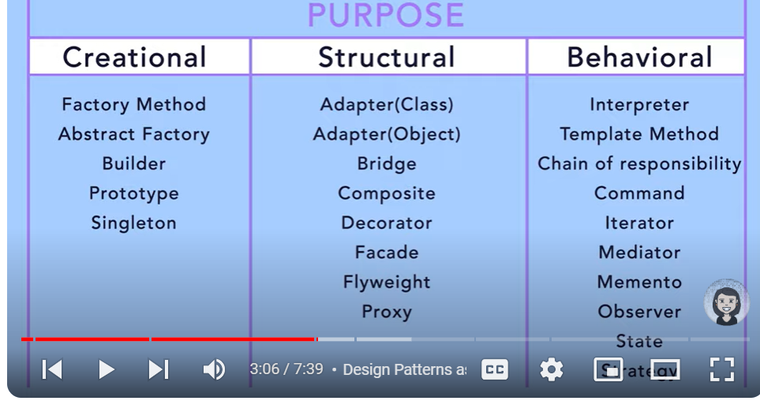

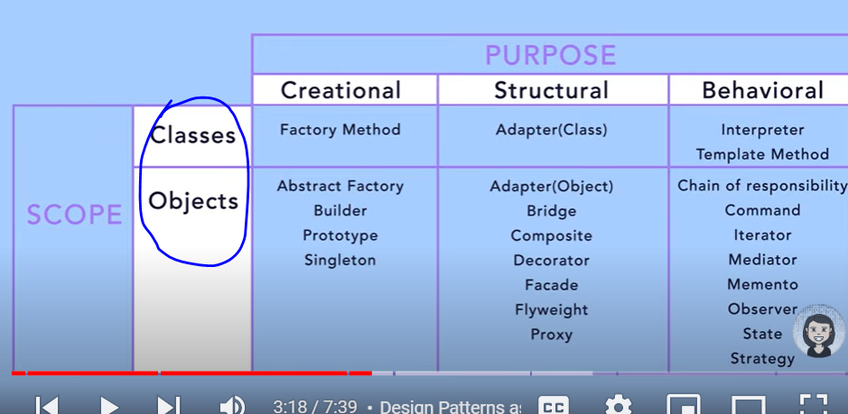

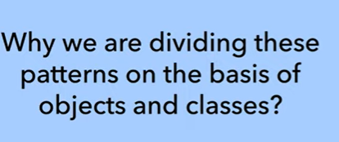

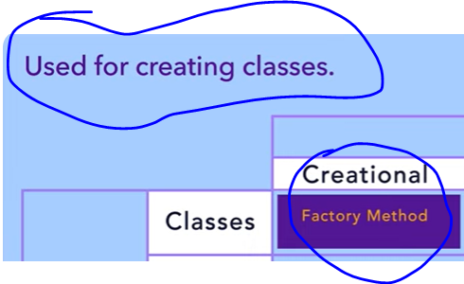

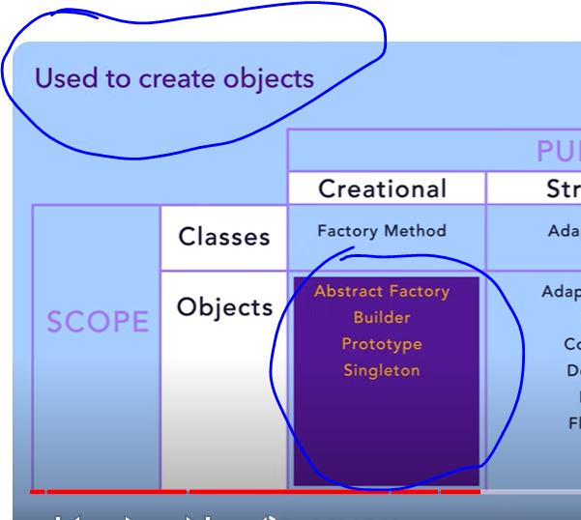

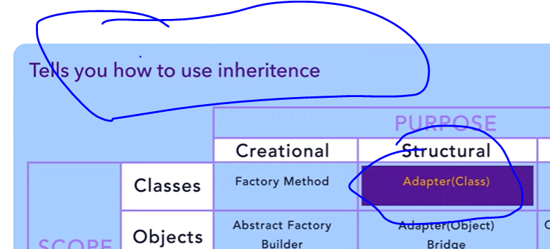

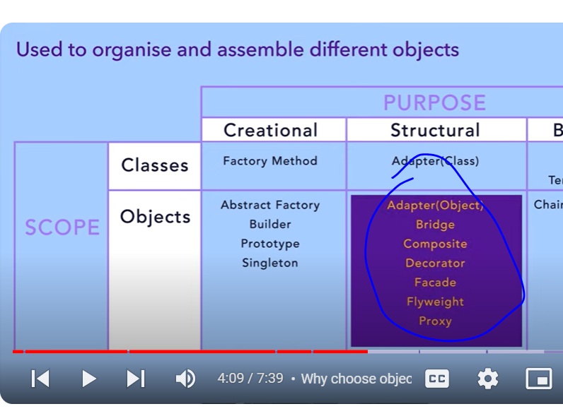

# Lecture 12 : How to use Factory Method Design Pattern

# 

# 

# It hides complexity of object creation

# Client code has no idea about object creation

# 